1. (a) (b) (c) -> Homework Exercises W2 Q4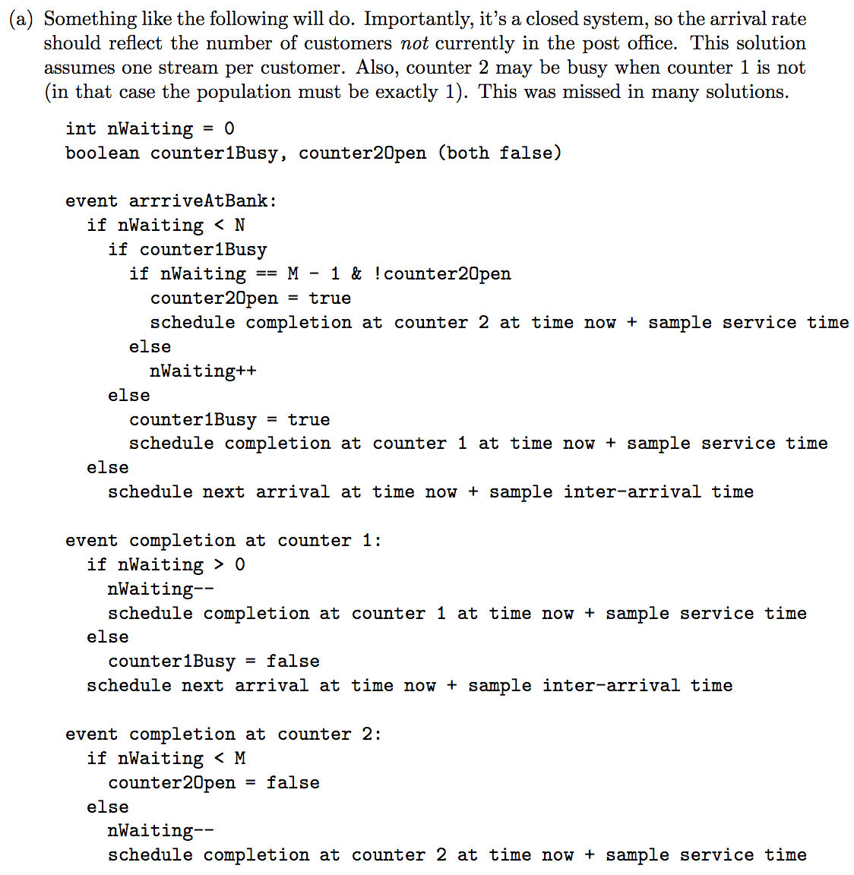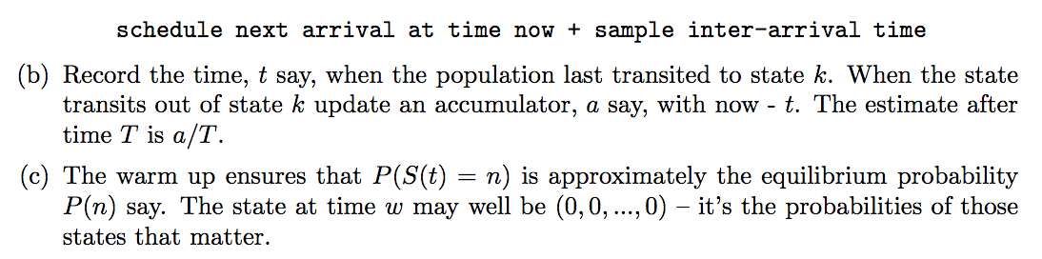

1d) -> Homework Exercises W1 Q2

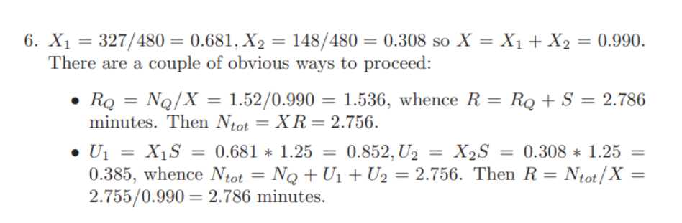

1. (a) Slide 37 of Part 1 Notes

(b) Schedule next event after executing previous event due to memoryless property(?)

(c) (d) -> In-Class Exercises W3 Q5 (b) (c)

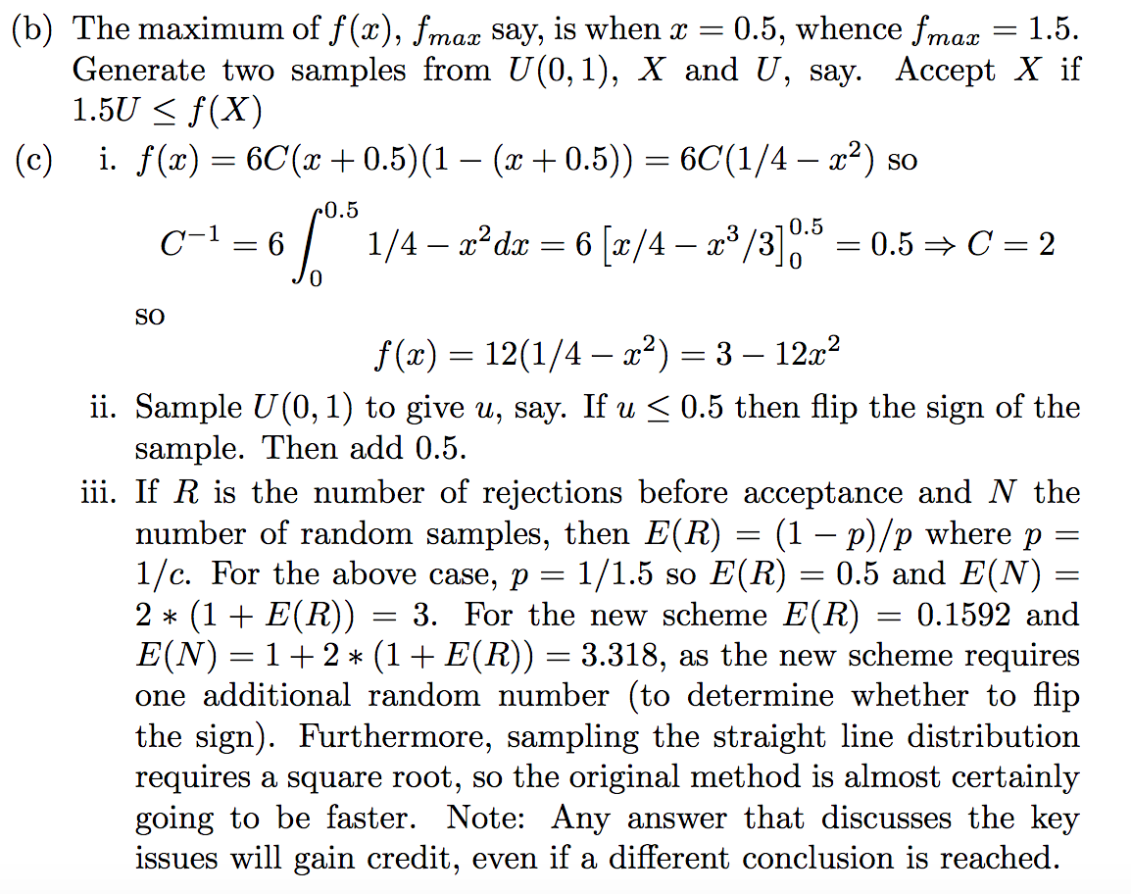

1. (a) -> In-Class Exercises W5 Q5

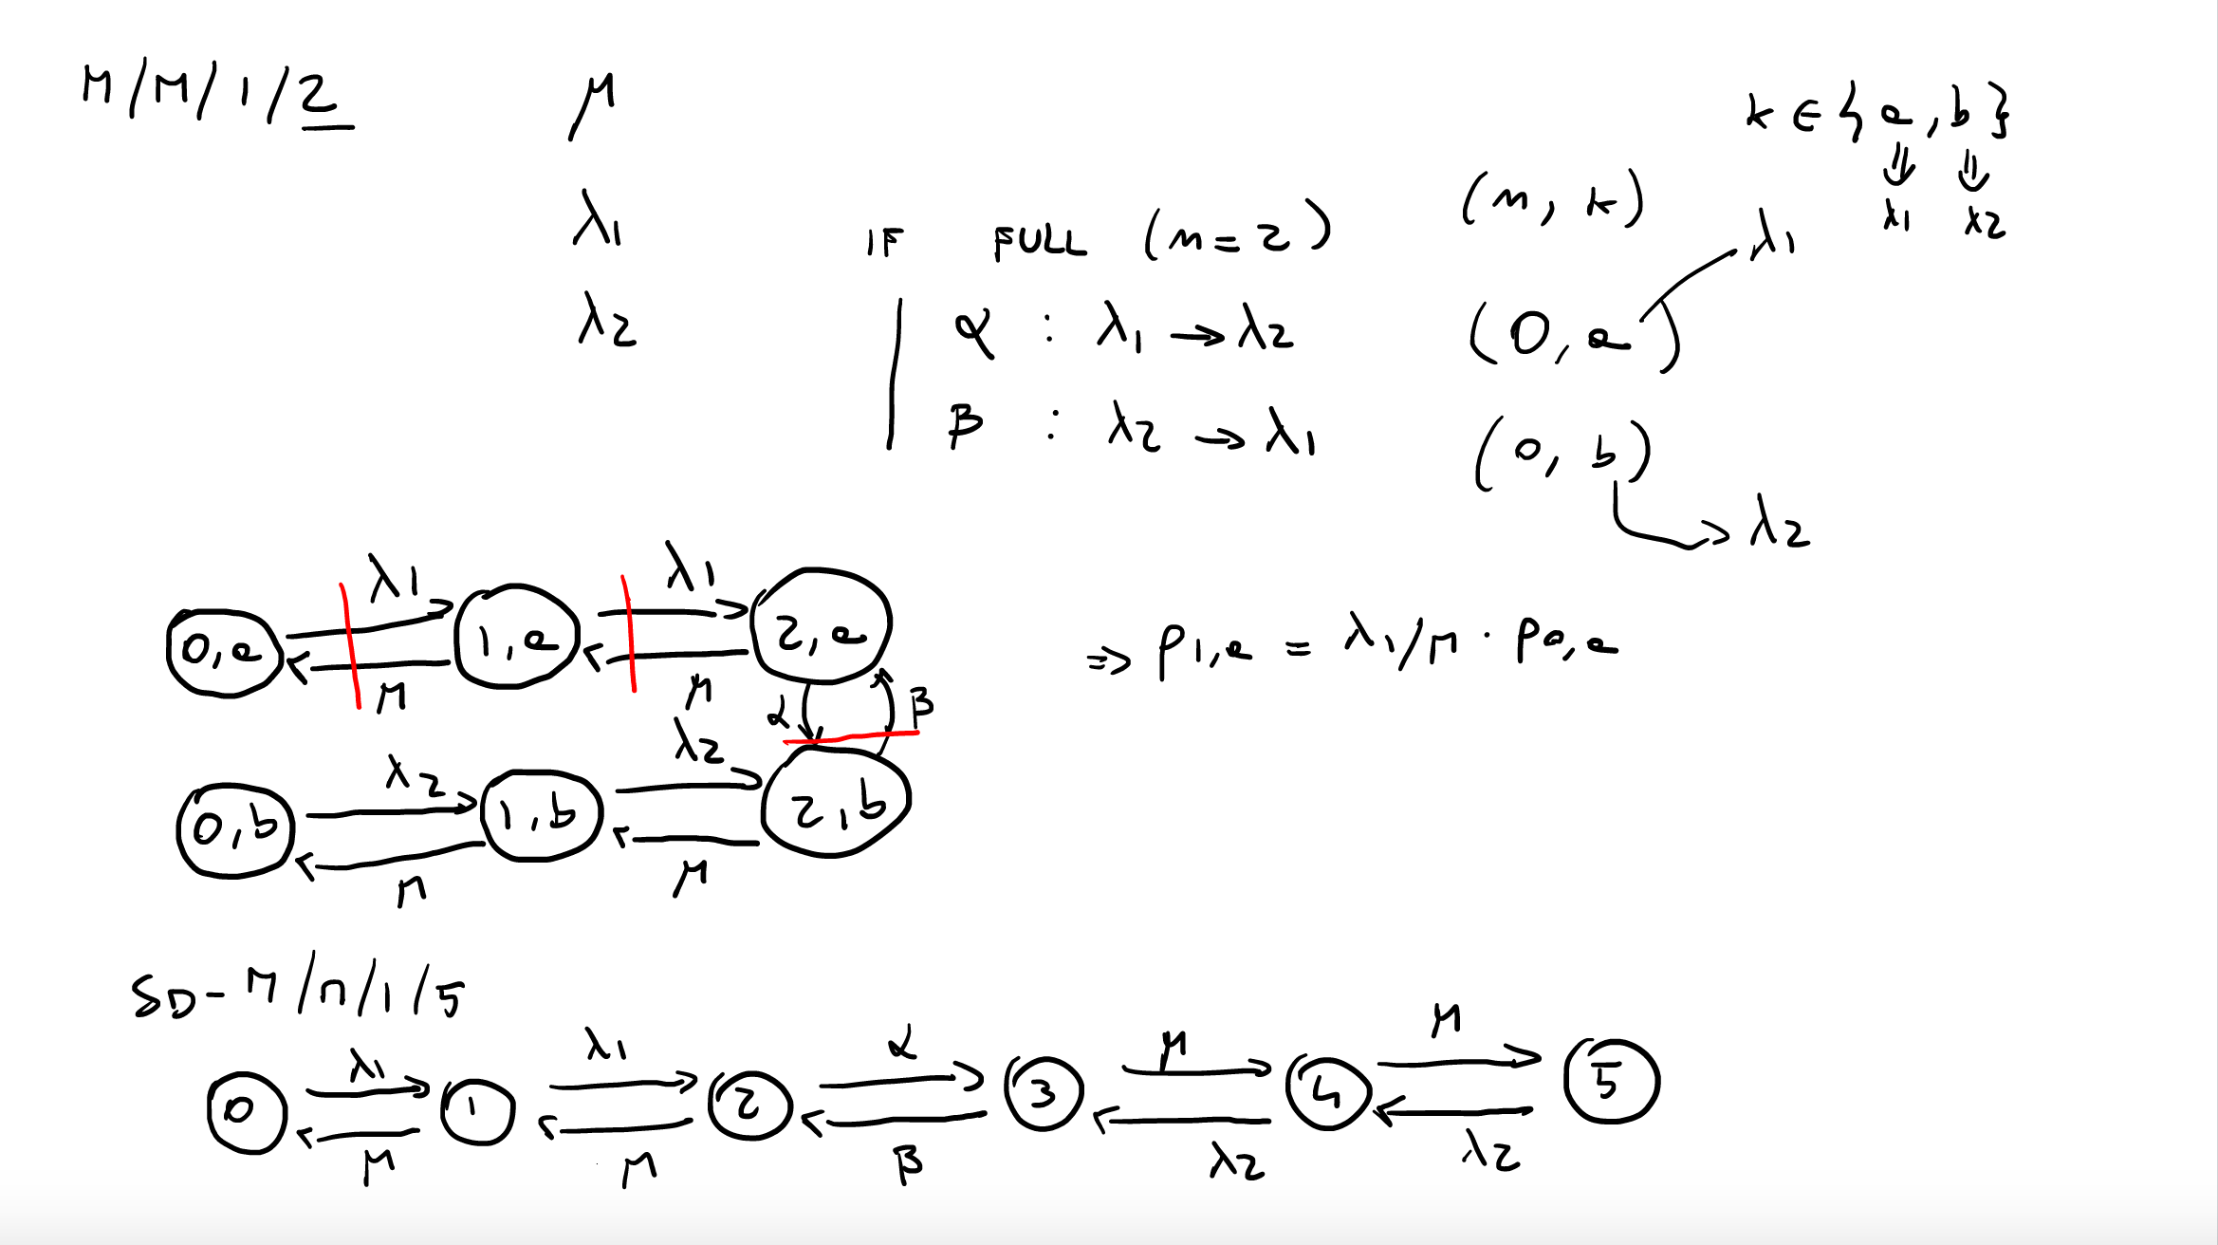

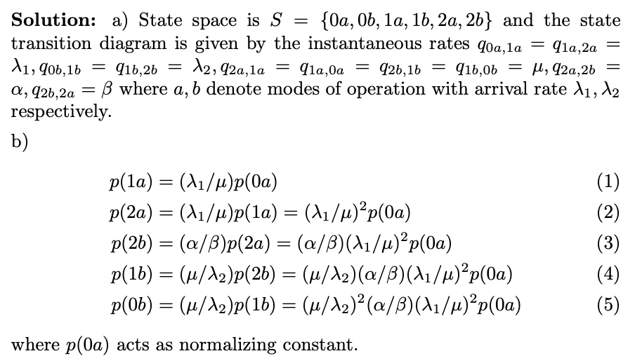

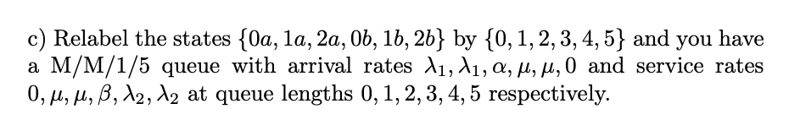

3b)(i) Slide 37 of Part 1 Notes

(ii) ?

(iii) H_n / lambda, where H_n = (1 + 1/2 + 1/3 + … 1/n) and lambda = rate of the exp distributions

1. Not relevant to 20-21 (is this relevant for 22/23???)